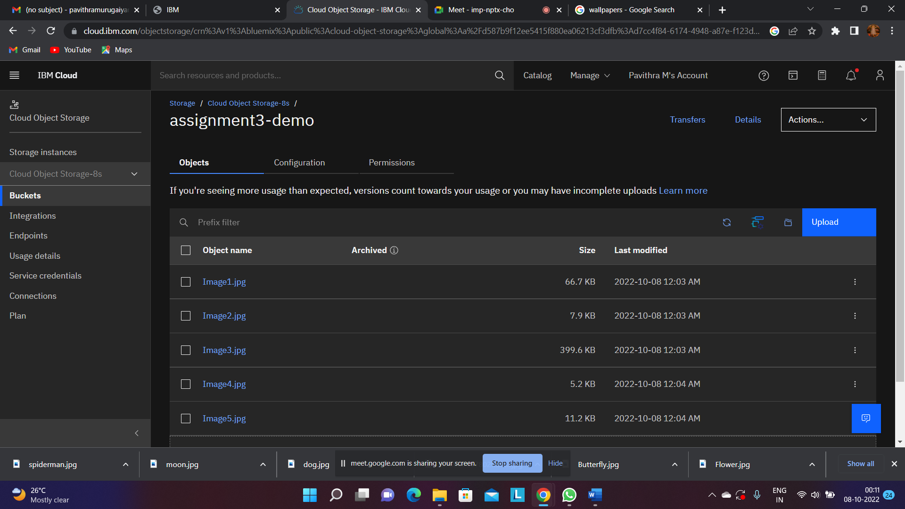

2.Upload an 5 images to ibm object storage and make it public .Write html code to display all the 5 images

